Andrew Allen, NIST Ceramics Division, December 2001:

SCATTERING MODELS FOR SBUSAXS AND MSANS STUDIES OF COATINGS

The following notes describe existing and proposed microstructural models for coatings that can be used to interpret small-angle scattering data. Multi-component single- scatter models are first developed (primarily for thermal-spray and EB-PVD TBC's).These are suitable for the interpretation of anisotropic SBUSAXS or anisotropic SANS experiments. Later the anisotropic MSANS formalism is developed for possible future coding in Igor or C,C++.

Basic Assumptions and Definitions

Assume an axis coordinate system with reference to the substrate-normal direction, n. Assume this is in the z direction so that, in vector notation, n = k. Let the polar angle measured from n be α and the equatorial (azimuthal) angle measured from an arbitrarily defined x axis be ω. Thus any direction with respect to the sample axes is given by direction cosines: cosω sinα i, sinα sinω j, cosα k. Note that when the reference axis, z, is perpendicular to the incident beam, the polar α-angle for Q with respect to the sample coordinate system, is approximately the same as the azimuthal angle (unfortunately), α_{LAB}, in the sample plane, with respect to the laboratory coordinate system used to define anisotropic USAXS or SANS data (see below). For the present, consider the angles, α and ω, defined for the microstructure with respect to the sample z-axis. Note also that we do not yet assume any microstructural symmetry with respect to this z axis.

Assume that the scattering morphology is composed of scattering elements, each of which does have a symmetry axis, i.e., the individual scattering elements are axially-symmetric. Each scattering element has an orientation with respect to the sample axes that can then be defined simply by the orientation of its symmetry axis in terms of α and ω. Furthermore, the orientational dependence of the scattering from a particular scattering element is determined solely by the angle, η, between this symmetry axis and Q. For a given orientation of Q with respect to the sample axes, α_{Q}, ω_{Q}, we have:

[1]

To calculate the scattering we need both the single-scatter cross-section function and the scattering-element orientation distribution as a function of α and ω. Furthermore we have to include and weight correctly the scattering associated with each of the three component void systems. To be general we denote these 3 systems as 1, 2 and 3, but we assume from the outset that system 3 consists of spherically-symmetric voids. (Later we introduce a possible 4th component of nanometer globular pores.) Thus, we have two anisotropic orientation distributions: P₁(α,ω) and P₂(α,ω), Q-orientations: X₁ and X₂, and: X₁ = cos η₁, X₂ = cos η₂.

We also need to consider the experiment (LAB) coordinate system, X, Y, Z, in which the incident x-ray or neutron beam is assumed to travel in the positive Z direction. If the angle of scatter is φ_{s}, then the component of Q parallel to the incident beam is: [ - (4π/λ) sin²(φ_{s}/2) ] and that in the sample plane is: [ (2π/λ) sin(φ_{s}) ] along a given experiment-frame azimuthal angle, α_{LAB}, for the USAXS or SANS data. The angle of Q to the incident beam is: [ (π/2) + (φ_{s}/2) ] and Q is swept back slightly by an angle, (φ_{s}/2), from the sample plane. To date, we have largely ignored this last point and assumed that Q lies in the sample plane with a magnitude, |Q| = Q = (4π/λ) sin(φ_{s}/2). We continue to make this assumption but we may eventually have to revisit this issue for EB-PVD.

Weighting of Cross-sections and Orientation Distributions

We proceed by considering how to weight the scattering contributions and orientation distributions from the three void components for a given sample orientation, Ω, with respect to the incident beam direction:

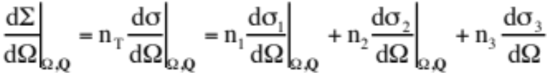 [2]

where (dΣ/dΩ)|_{Ω,Q} and (dσ/dΩ)_{Ω,Q} refer to the macroscopic and microscopic single-particle scattering cross-sections, respectively, orientationally-averaged for a particular sample orientation and a given direction of Q; n_{T} = n₁ + n₂ + n₃ denote the total and component void number densities, and there is no orientational dependence for component 3, as discussed above. The number densities can be derived from the total and component void volume fractions (porosities), Φ, from: n₁ = γ₁Φ_{T}/V₁, n₂ = γ₂Φ_{T}/V₂, and n₃ = γ₃Φ_{T}/V₃, where γ₁ + γ₂ + γ₃ = 1, and V₁, V₂, V₃ are the average single-particle volumes for each of the three components. In the context of our existing model, note that V₁, V₂, V₃ are effectively the mean volumes of our volume-elements that comprise each of the component void systems. In general, V₁ and V₂ are NOT the volumes of complete cracks or planar pores.

For each of the anisotropic components, with a given sample orientation and a given Q direction, we need to compute the correct orientational average for (dσ/dΩ)_{Ω,Q}. For component 1, we need to consider the orientation distribution of the volume-elements with respect to the sample coordinate system, and also deduce the direction of Q in this same coordinate system:

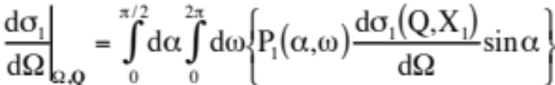 [3]

where P₁(α,ω) integrates to unity if taken over the 2π solid angle considered and X₁ is determined from α, ω, α_{Q}, and ω_{Q} using X₁ = cosη₁ and equation [1]. An analogous expression applies for component 2.

We next need to consider the form of P₁(α,ω) and P₂(α,ω). For plasma-spray deposits, we have previously assumed distributions that are axially-symmetric about n and have assumed 3 simple weights for (otherwise) random distributions within each of the angular ranges: 0 < α₁ < π/6, π/6 < α₁ < π/3, and π/3 < α₁ < π/2, where π/6 = 30° etc.). The respective weights-over-random are p_{L1}, p_{M1} and p_{H1}, and there is no dependence on ω₁. To satisfy the boundary condition for P₁(α,ω) the weights must satisfy the constraint: 0.134p_{L1} + 0.366p_{M1} + 0.500p_{H1} = 1. Corresponding weights, p_{L2}, p_{M2} and p_{H2}, are defined for component 2 with a corresponding boundary condition. Unfortunately, while P₁(α,ω) and P₂(α,ω) do not depend on ω, dσ₁(Q,X₁)/dΩ and dσ₂(Q,X₂)/dΩ do, because X₁ and X₂ depend on both ω and α. In the case of plasma-spray deposits, for given α_{Q} and ω_{Q} with given α, the ω-integration has consisted of a linear average for ω-values at π/12 intervals. Combining axial symmetry assumptions with approximating Q to lie in the plane of the sample leads to a major simplification at this point. When the sample is oriented with n parallel to the incident beam (X orientation), α_{Q} = π/2, ω_{Q} can be arbitrarily set to zero, and dσ₁(Q,X₁)/dΩ obtained by 2D averaging over all ω sector angles in π/12 steps for each weighted polar angle α. In this case we obtain: cos η₁ = cos α sin ω. When the sample is oriented with n perpendicular to the incident beam (Y-orientation), α_{Q} = α_{LAB} and ω_{Q} can be defined as zero provided there is axial symmetry. Thus: cos η₁ = cos ω sin α sin α_{LAB} + cos α cos α_{LAB}, with the ω-averaging carried out as before in π/12 intervals, and similarly for α using the weights p_{L1}, p_{M1} and p_{H1}, as defined previously. A similar process is carried out independently for dσ₂(Q,X₂)/dΩ in terms of η₂ as a function of ω, α, and α_{LAB} using weights p_{L2}, p_{M2} and p_{H2}. It is this independent orientational averaging of the two anisotropic components and the summation of their contributions with that of the spherically symmetric component 3 which allows a relatively straight forward computation of the total cross-section using equation [1].

When axial symmetry conditions do not apply (as for EB-PVD), we either need to determine full orientation distribution functions or we need to apply two weighting factors: one for the polar angle as defined above, and the other for the equatorial (azimuthal) angle with respect to some convenient reference direction within the substrate plane. Preliminary analysis of EB-PVD suggests that we may retain a 3-(or possibly 4)-component model but with the 3 components corresponding to different void systems from those considered in plasma-spray deposits:

PLASMA SPRAY EB-PVD
COMPONENT 1: intrasplat cracks intracolumnar voids
[Preferred orientation: perpendicular to substrate ± 45° to substrate]
COMPONENT 2: interlamellar pores intercolumnar pores
[Preferred orientation: parallel to substrate perpendicular to substrate]
COMPONENT 3: large globular voids fine globular pores
[Typical size: ~ 1 micrometer tens of nanometers or ~ 1 μm]

For compatibility with MSANS analysis, the use of fixed weights for different parts of the orientational averaging is probably most practical. For plasma-spray, but not for EB-PVD, we could also consider the alternative of using the Mach-Dolase function and variation s thereof to give the orientational distributions. This uses fewer parameters and is a continuous and differentiable function but it does not have a form that peaks in the middle of the angular range. Thus, it is not suitable for modeling the intracolumnar voids in EB-PVD.

For complete generality, P₁(α,ω) and P₂(α,ω) must be considered arbitrary functions of α and of ω. This implies that one or both of the ω-anisotropies in the component orientation distributions could depend on the value of α. Here, we simplify by defining: P₁(α,ω) = p1(α)b1(ω) and P₂(α,ω) = p2(α)b2(ω) where p1 and p2 could be defined within the L, M and H ranges of α in each case with the same boundary conditions as before. Note that this implies there is no variation in ω-anisotropy with α. Given the extreme anisotropy of the EB-PVD system we should increase the number of angular ranges, perhaps to six: 0 < α < π/12, π/12 < α < π/6,. π/6 < α < π/4, π/4 < α < π/3, π/3 < α < 5π/12, and 5π/12 < α < π/2, (where π/12 = 15°) with the probability weights-over-random denoted as p1₁, p1₂, p1₃, p1₄, p1₅ and p1₆ for population 1, and p2₁, p2₂, p2₃, p2₄, p2₅ and p2₆ for population 2. The boundary conditions for p1 and p2 are then: 0.034p1₁ + 0.100p1₂ + 0.159p1₃ + 0.207p1₄ + 0.241p1₅ + 0.259p1₆ = 1 with a similar condition for p2. For the b1 and b2 probability weights-over-random, π/18 (10°) wide sector-averages are suggested, centered on ω = 0, π/18, π/9, π/6, 2π/9, 5π/18 etc., and linearly indexed over an azimuthal angle range of π (180°) to give b1₁, b1₂,…b1₁₈. The linear sum of these weights must total to unity to satisfy the boundary condition for each anisotropic void population.

While possible ways of parameterizing the orientational distributions have been outlined in terms of fixed weights that apply over particular angular ranges, this should NOT be confused with the orientational increments required to produce good integration results from equation (3). Given the strong anisotropies encountered with the EB-PVD system, we should consider using increments in both α and ω of 1° or less (π/200 already being used in anisotropic MSANS).

Finally, we must consider the detailed forms of dσ₁(Q,X₁)/dΩ and dσ₂(Q,X₂)/dΩ for given orientations, X₁, and X₂, of the scattering volume elements of populations 1 and 2, with respect to the direction of Q.

Computation of Individual Cross-Sections:

For simplicity we drop the subscript for a given anisotropic void population and consider the general case of an arbitrarily-oriented scattering element with respect to the direction of Q. We also assume not only axial symmetry for the scattering object but that it is an oblate spheroid of aspect ratio, β, and orthogonal radii: R_{O}, R_{O} and βR_{O}. Thus, V = 4πβR_{O}³/3 and a given orientation, X, is defined solely by the angle, η, between the short βR_{O} axis (the axis of symmetry) of the individual scattering element and the direction of Q. While using oblate spheroids as the scattering elements, we acknowledge that the true void population consists of an interconnected network of such elements with the mean opening displacement, <O.D.>, equal to 2/3 of the maximum opening, 2βR_{O}, i.e., <O.D.> = 4βR_{O}/3.

Due to the size of the large features, refraction effects must be taken into account, as well as diffraction. The criterion for having to consider refraction is the phase shift between neutron or x-ray de Broglie waves passing through the scattering void and passing around it. A suitable phase parameter is ν_{O}, defined in the present case by: ν_{O} = 2R_{O}|Δρ|λ, where |Δρ| is the scattering length density difference between void and matrix. When ν_{O} « 1, diffraction only need be considered. However, for the coarse voids considered here, this is not the case in either SANS or SAXS. The full expression for the differential scattering cross-section is given in terms of the product of the scattering form-factor with its complex conjugate:

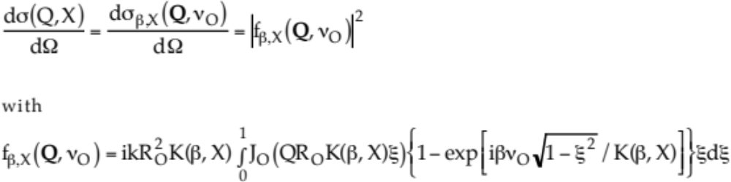 (4a)

where K(β,X) = [1 + (β² – 1)X²]^{1/2} with X = cos η, ξ is a dimensionless integration variable, and J_{O}(x) is the Bessel function of zero order. An equivalent expression, which removes the integral at the cost of having an infinite converging series, is given by:

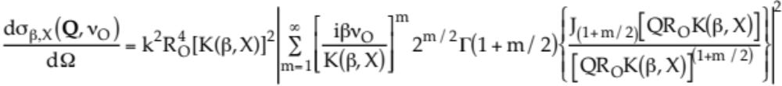

(4b)
where Γ(x) denotes the Gamma function and J_{(1 + m/2)} is the Bessel function of order (1 + m/2). In the limit of ν_{O} « 1, equation (4) reverts to the well-known diffraction-limit expression for scattering from a spheroid ("m = 1" term only in equation (4b)):

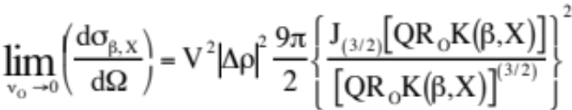 (4c)

where |Δρ|² is the scattering contrast.

While not essential for single-scatter analysis, it is useful to give the expression for the total scattering cross-section, σ_{X,T}. Note that this total cross-section is for scattering over all 4π steradians scattering angle while maintaining a particular fixed orientation of Q with respect to the βR_{O} symmetry axis:

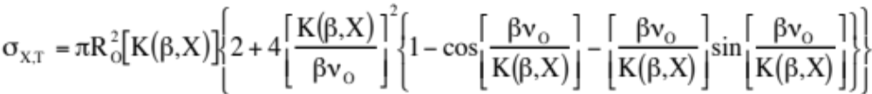 (5a)

which in the diffraction limit of [βν_{O}/K(β,X)] « 1 becomes:

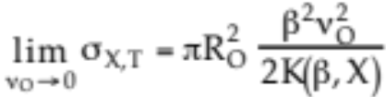 (5b)

A weighted orientational average over the range X = 0 to 1 gives the actual total cross-section, σ_{T}, for a given sample orientation with respect to the incident beam direction. For single scattering, the product, nσ_{T}τ_{s} « 1 where τ_{s} is the sample thickness. When this is not the case, = nσ_{T}τ_{s} is a measure of the multiple scattering and this is used further in multiple scattering analysis. This is also the weighting factor for combining void components when calculating the overall anisotropy in the scattering profile width. Note that the globular void components are easily treated in the above formulae by setting β = K(β,X) = 1 and eliminating the orientational averaging step.

Summary for Anisotropic Single-Scattering Model

To model the anisotropic single-scattering versus Q, as observed, for example, by SBUSAXS, we should probably consider up to 4 components: oblate spheroids 1, oblate spheroids 2, micrometer-sized globular pores 3, and nanometer pores 4. These should be assigned radii, R_{O1}, R_{O2}, R_{O3}, R_{O4}; volume fractions, Φ₁, Φ₂, Φ₃, Φ₄; and aspect ratios, β₁, β₂. The β-values should be fixed as appropriate (but need not be exactly 1/10 or 1/5 as used for MSANS). The R_{O}-values and the Φ-values can be independent fitting variables. Alternatively, if the total porosity, Φ_{T}, is accurately known, we can fit γ₁, γ₂, γ₃, γ₄; (Φ₁ = γ₁Φ_{T} etc.) subject to the constraint γ₁ + γ₂ + γ₃ + γ₄ = 1. The orientational weights, p1_{1,2,..6}, b1_{1,2,…18}, p2_{1,2,..6}, b2_{1,2,…18}; need to be estimated by inspection of the anisotropic azimuthal scans in SBUSAXS or from the observed anisotropy in SANS data and should be fixed for any one fit. However, as with anisotropic MSANS analysis, they can be adjusted to better match the experimental anisotropy. With these parameters determined the single-scattering can be modeled for all Q using equations (1) - (5), extended to include a 4th component as appropriate.

Scattering Anisotropy

In order to fit the overall model to the observed scattering, we should consider two modes of fitting. One of these should apply equations (1) - (5) to the absolute-calibrated scattering as a function of Q for fixed orientation of Q. The other should apply these same equations to data at fixed Q as a function of the angle, α_{LAB}, giving the orientation of Q. This latter mode may need to be applied to anisoscan data without a full absolute calibration.

Other anisotropic modeling should be considered. One obvious requirement is to be able to model the anisotropy in the Porod scattering. This can be done by replacing equation (4) with that for the anisotropic Porod scattering from a spheroid. The orientational averaging and weighting of the components can then proceed as before. In the diffraction limit the required expression is:

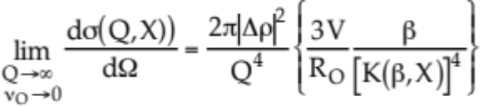 (REGULAR SPHEROIDS) (6a)

where the product of the number density, n, times the expression in {} brackets, orientationally-averaged with respect to the direction of Q, gives the apparent Porod surface area per unit sample volume for the particular void system considered, S1_{APP, X} etc. While refraction is neglected here this is not generally found to be an issue for Porod scattering investigations. However, equation (6a) is very specific to the geometry of the spheroidal elements used to model void systems 1 and 2, and it amplifies the true anisotropy due to coherent scattering effects arising from their regular spheroidal shapes. Thus, it is useful to model the anisotropic Porod scattering from disordered interfaces that reflect the actual surface area orientation distribution:

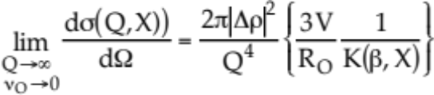 (IRREGULAR OBLATES) (6b)

In practice, the Porod scattering anisotropy can be expected to lie be between these two limiting cases. However, it should be noted that only equation (6a) integrates over all solid angle to give the correct total surface area of a regular spheroid. In the aniso33_look program used in our present anisotropic multi-component MSANS analysis, equation (6a) forms the basis of derivation of the PORODXY anisotropy parameters and equation (6b) forms the basis for deriving the SURFXY anisotropy parameters.

In the anisotropic Porod analysis, equation (6a) or (6b) is used in place of equation (4), the orientational integration is performed for each anisotropic component according to equation (3) using equation (1) to determine X, and the components are weighted to give the overall result using equation (2). One other anisotropic variation is of interest for which the weighting of the components is different to that given by equation (2). This is the anisotropic variation in the width of the scattering profile (essentially, the anisotropic variation of the inverse of the Guinier radius). Not only can this anisotropic variation give an indication of the scattering anisotropy in different Q (scale) ranges away from the final (high Q) Porod scattering condition, but it also predicts the anisotropy in multiple scattering broadening that must be modeled in anisotropic MSANS analysis. For a given orientation of a general spheroid with respect to Q, the scattering profile width is proportional to 1/{R_{O}K(β,X)} as in equation (6b). However, the orientational averaging for each component must now include not only the orientational weighting given in equation (3), but also some allowance for changes in the total cross-section with orientation. Similarly, the overall weighting of the contributions from the different void components must also take into account the different total cross-sections if the correct profile-width (and MSANS beam-broadening) anisotropies are to be correctly modeled. Thus, we have:

(7)
where σ1 and σ2 refer to the total cross-sections for particular spheroid orientations for void populations 1 and 2, and we have included 4 components in order to treat both micrometer and nanometer globular voids. Note that multiplication by the sample thickness, τ_{s}, would give the weighting referred to above. Equation (7) is the basis of derivation for the BKINVXY anisotropic parameters in the present MSANS aniso33_look program.

Extension to Anisotropic Multiple Scattering (MSANS) Analysis

Anisotropic multiple scattering analysis comprises the modeling of circularly-averaged anisotropic MSANS data for different orthogonal sample orientations, subject to the conditions that the model microstructure must give the correct variation with wavelength in the width of the multiple scattered beam profile for each sample orientation, the MSANS anisotropy must be predicted correctly, and both the total porosity and surface area must also be correctly predicted. However, it is important to consider at the outset whether all the void components are included in the MSANS analysis. Very large features that give a large amount of multiple scattering but for which the broadening remains within the empty beam must be excluded; so must their contribution to the total porosity (large?) and surface area (small?) be excluded. Also, very fine features, which give a very broad scattering profile but with a small scattering cross-section that gives no multiple scattering involved, must also be excluded together with their porosity (small?) and surface area (large). Unfortunately, there is no way of recovering information on the very large features but single-scatter SANS or USAXS can be used to obtain the fine pore information….

Computational Form for MSANS Analysis

……TO BE CONTINUED…..

